REPUBLIC OF BENIN

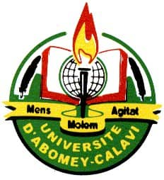

---0---

MINISTRY OF HIGHER EDUCATION AND SCIENTIFIC RESEARCH

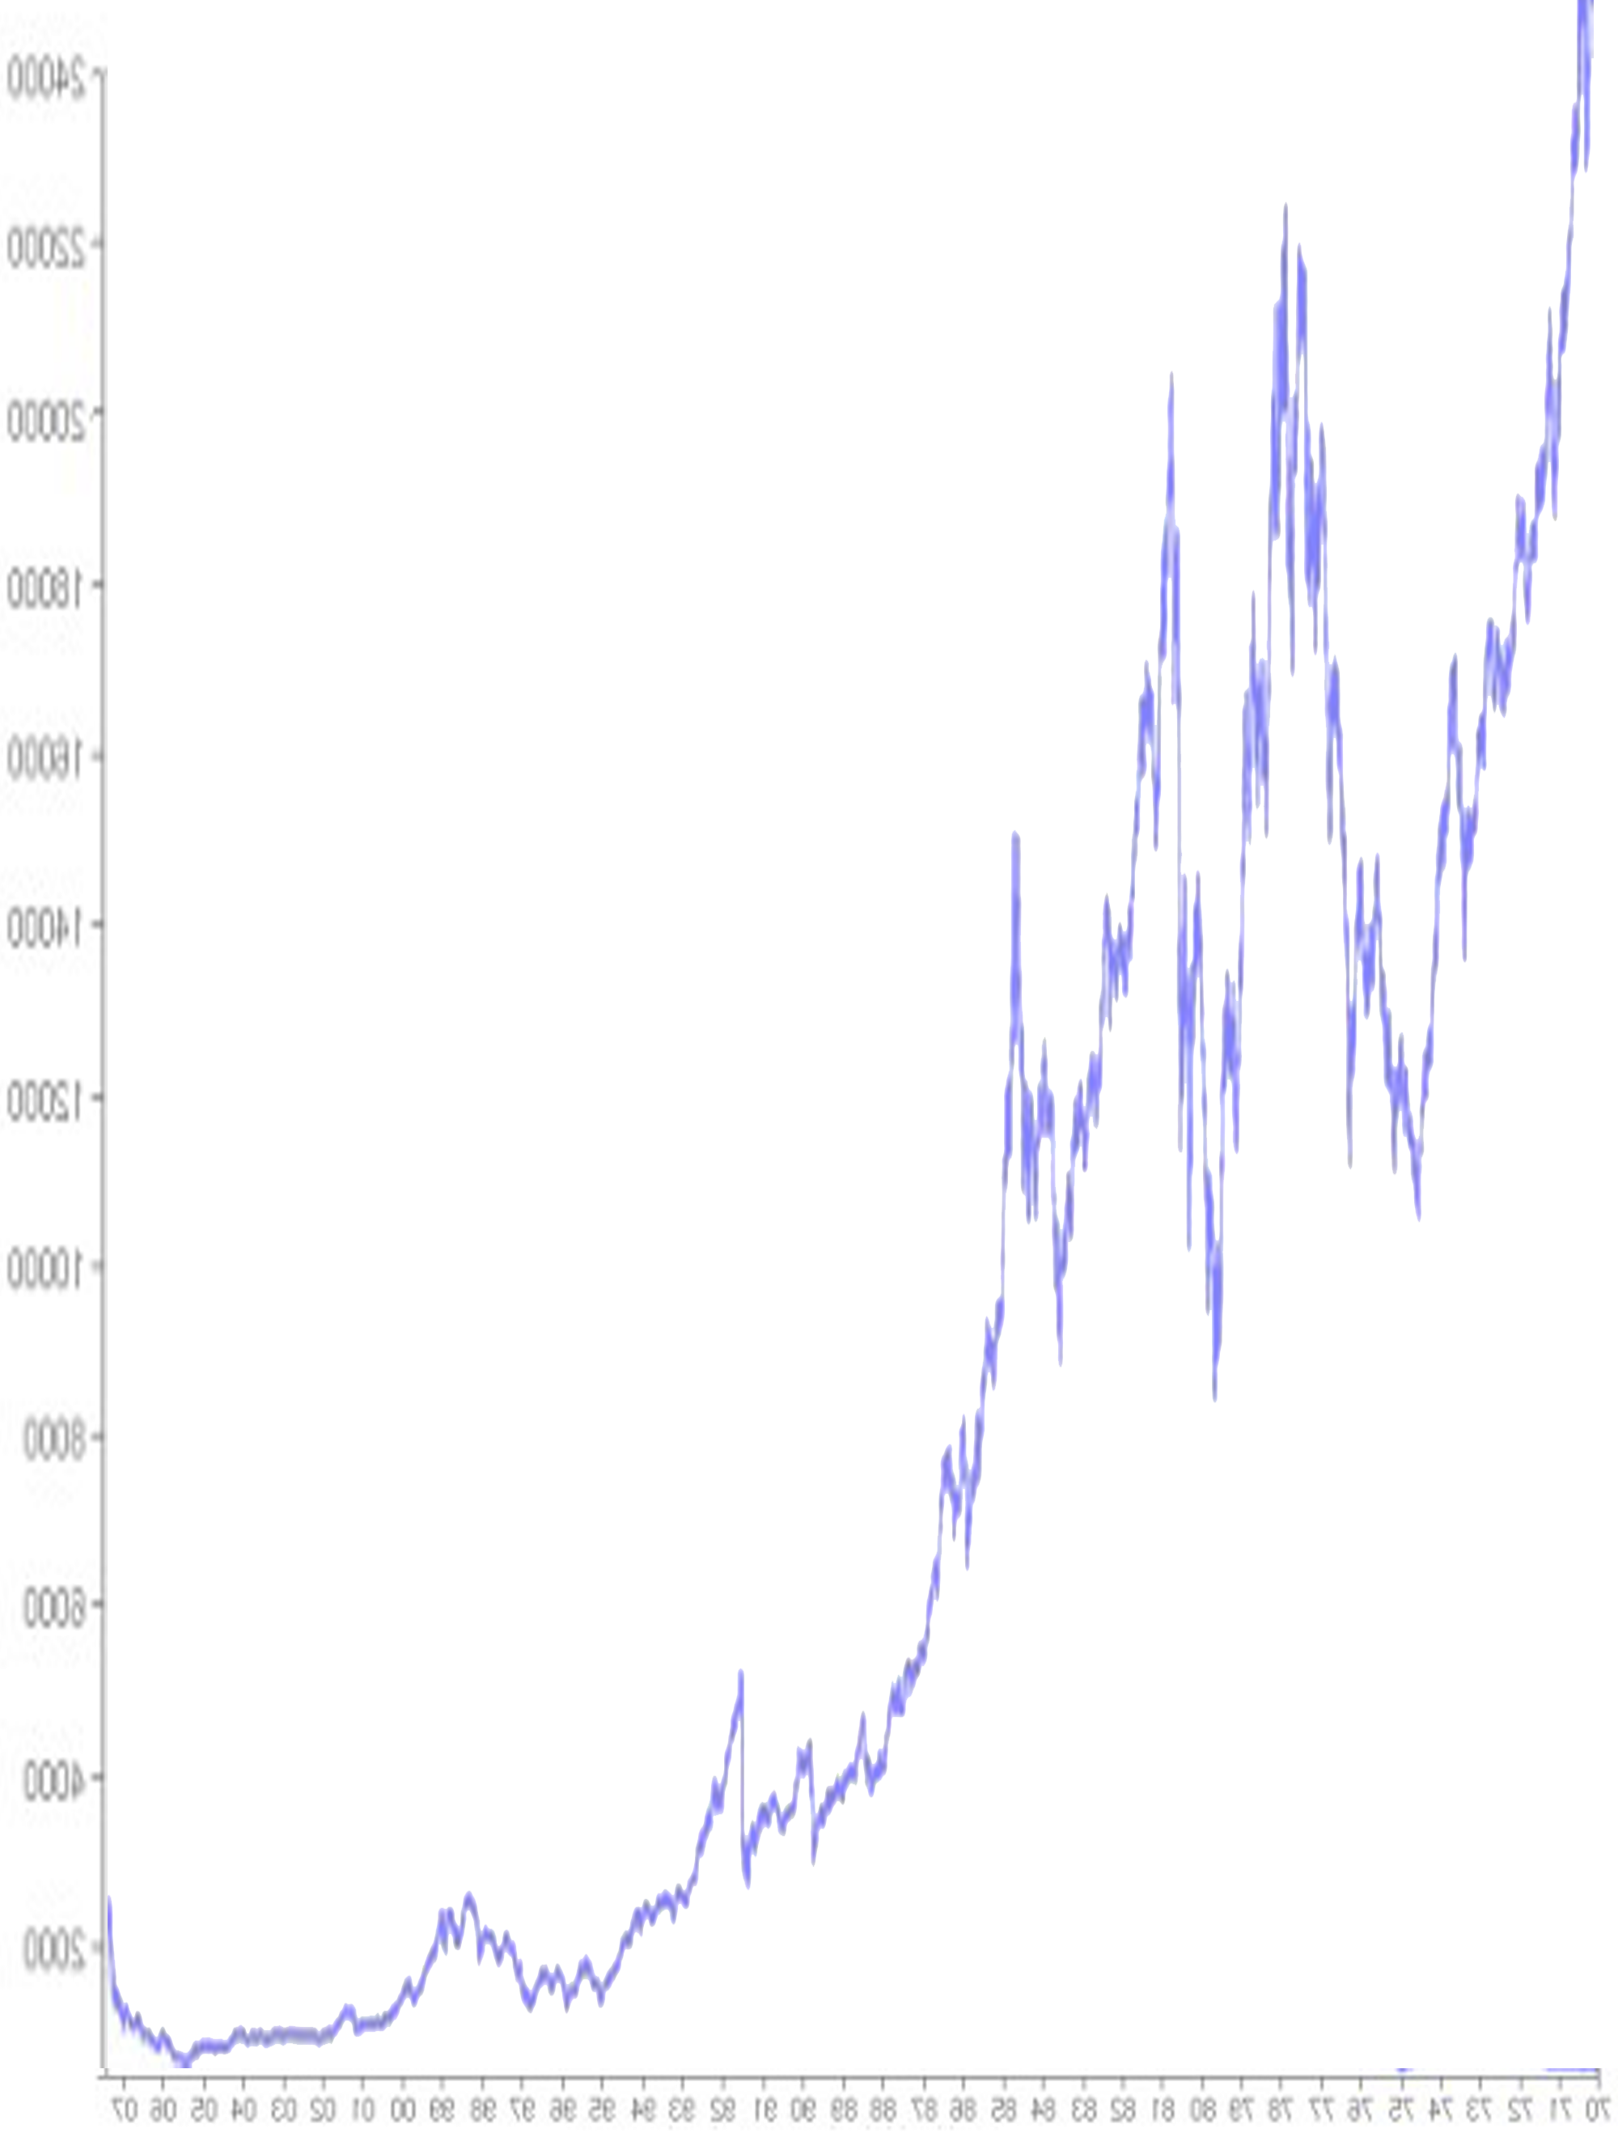

-----0-----

UNIVERSITY OF ABOMEY-CALAVI

----0----

BENINESE CENTER FOR FOREIGN LANGUAGES

(CEBELAE)

----0----



stock exchange



**Level**: Intermediate (B1)

**Delivered by: Professor:**

Marnel **GNACADJA**  **Mr** Christopher **KADI**

**Academic-Year: 2019-2020**